PPE Compliance Conformance
Before purchasing PPE for your premises, ensure that it meets the EU/BS certification standard.
Compliance with the EU legislation on PPE (Regulation (EU) 2016/425) ensures that PPE are safe to be used by the wearer and at the same time offer the necessary and claimed protection.
Ask for Safety Data Sheet with the purchase of hand sanatiser and any other chemical based items.
Ask for manufacturer guidance for equipment purchased in response to covid-19.
Ask for relevant certification conformity paperwork with all your PPE purchase.
PPE | Essential Technical Requirements | Relevant standards for design and performance
Type I, II or IIR (Fluid Resistant Surgical Mask) Surgical Masks  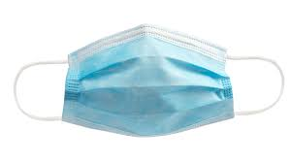 | •Must indicate masks type of mask. ‘Type I’ (if it complies with BS EN 14683) or should state ‘not fluid resistant’ as appropriate  •Must indicate masks type. ‘Type II’ (if it complies with BS EN 14683) or should state ‘not fluid resistant’ as appropriate  •Must indicate type of mask. ‘Type IIR’ (if complies with BS EN 14683) or should state fluid or splash resistant as appropriate if equivalent test for splash resistance has been carried out  Should have an expiry date | CE marking to ensure compliance with EU health, safety and environmental protection legislation and confirms a product's compliance with relevant requirements. affixed with CE marking    Or  BS EN 14683:2019  Medical face masks. Requirements and test methods  or  ASTM F2100 minimum Level 1  or  equivalent technical solution
Disposable latex gloves  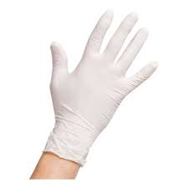 | •Must be labelled STERILE along with the method of sterilisation  Gloves containing latex must be labelled with the symbol for latex on at least the smallest packaging unit and caution placed in the instructions for use against its use where there is a known allergy to latex.  •Must have an expiry date  •Must specify the size | BS EN 455-1:2000  Requirements and testing for freedom from holes.  or  BS EN ISO 374-2  Protective gloves against dangerous chemicals and micro-organisms.  Determination of resistance to penetration.  BS EN 455-2:2015  Requirements and testing for physical properties.
Disposable Apron   | Latex-free, with halter neck and waist ties | Apron should be manufactured in accordance with European PPE Directive 89/686/EEC.  and  Partial body garments (e.g. gowns, aprons, etc.) has to comply with all of the applicable requirements of EN 14605 or EN 13034  Or  CE Marked
Eye protection  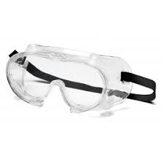 | Eye Shields/safety glasses are devices for protecting the eyes against exposure to liquid droplets. All safety glasses must comply with the following:  •Must be optically clear.  •Should be resistant to fogging.  •Must be resistant to droplets and splashes.  Marking and Packaging Requirements: as specified in BS EN 166:2002  Manufacturer’s Instructions and Information to be  provided: as appropriate and as specified in BS EN 166:2002  Note: If re-usable manufacturer should provide specific  instructions for cleaning and disinfection. | BS EN 166:2002  Personal eye protection  or  Technical Specification to satisfy the requirements of Annex II of PPE Regulation (EU) 2016/425  or  CE Marked
Hand Santiser

