**School Circular Handbook**

**Preparations**

**Access needed**

1. School Circular Inbox
2. Campaign Monitor Account:   
   <https://designteamlbb.createsend.com/>

* Email: [nick.burr@barnet.gov.uk](mailto:nick.burr@barnet.gov.uk)
* Password: Buffy9000

1. Working With Children in Barnet Drupal Account: <https://admin.wwc.barnet.gov.uk/user/login>

* Username: NickBurr
* Password: Barnet123

**Process**

The broad process for creating the circular goes as follows:

1. Check inbox and collect entries
2. Draft a list of entries, including number of attachments
3. Save attachments in a folder in the shared drive:   
   S:\Education_&_Skills-016\BUSINESS_SUPPORT-016-03\COMMUNICATIONS\00_SCHOOL CIRCULAR\2019-20\2020 Spring Term
4. Begin a draft of the circular in Campaign Monitor
5. Enter, proof-read and format text for each item
6. Use the WWCiB Drupal account to create URLs for each attachment
7. Link attachments into circular
8. Send draft to E&S Director for final sign off and proof reading
9. Make any amendments requested by E&S Director
10. Send to all recipients via Campaign Monitor
11. Send as email to all E&S Staff

**Basic requirements for item inclusion**

All entries need to have the following –

* A title
* Text to go in the main body of the circular
* A named person that the piece is coming from, including their job title and organisation
* Any attachments , if they are necessary

If anybody submits a piece but neglects to include these, please get in touch and inform them as soon as possible to allow them to prepare.

**Drafting a list of entries**

It is worth deciding the order before entering everything into the circular. Order all the pieces on a piece of notepaper (example pictured below). If any attachments need to be included, make a note of this, also showing how many there are.

It is generally a good idea to limit the circular to 15~16 items

In deciding the order, the general priority to follow is –

1. High Priority (Items sent directly by Ian, Ofsted news, Admissions, Finance etc.)
2. Items coming from the E&S department (Safeguarding, training/conferences run by E&S teams, ertc.)
3. Items being sent in from other council departments (libraries, Family Services etc.)
4. Items not directly related to Barnet Council that may interest schools nonetheless (this is mostly charitable initiatives)
5. Items sent in from schools directly (mainly schools posting about winning awards etc.)

The Director has final say on the inclusion and order of all items.  
  
An example of a drafted list:

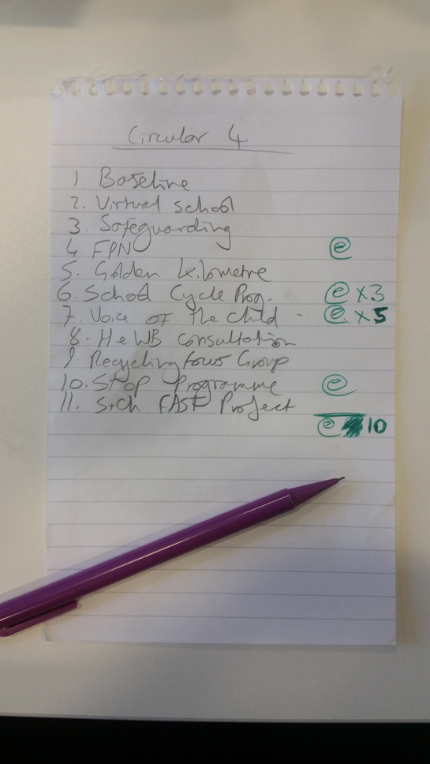

**Creating a Draft**

**Creating a draft on Campaign Monitor**

Log in to Campaign Monitor as detailed above.

1. Switch the selected option at the top of the page from “LBB: Communications – Internal” to “Cambridge Education”.
2. Click on the green “Create a new campaign” button
3. Enter the circular name in the name and subject line. The name should follow this format: *School Circular Issue* ***XX*** *– Wednesday* ***DD Month Year***  
     
   i.e.: School Circular Issue 20 - Wednesday 5 February 2020
4. “Chose a starting point” – select a recent draft to use as the basis of your circular. Look for the latest version that is called DRAFT and has no text entered (i.e., where there should be text you can only see XXXs)

**Editing your draft**

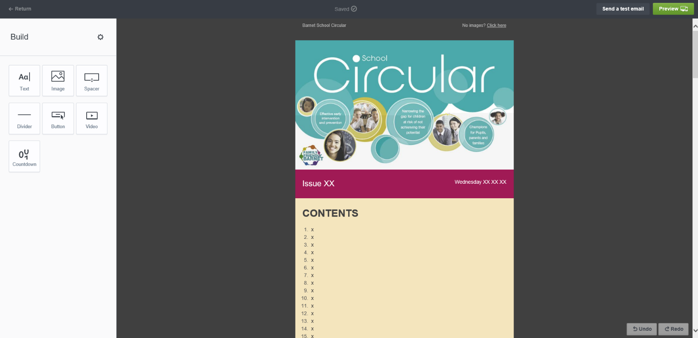Your open draft should look something like this:

Firstly, enter the issue number and date information in the magenta bar. Leave the contents list for now, we will be filling that in later.

Next, go down to the numbered items, and fill them in with the required text, ensuring to remember the titles.

To edit, click on the area where the text should go, to bring up the text editing box. It should be fairly self-explanatory:

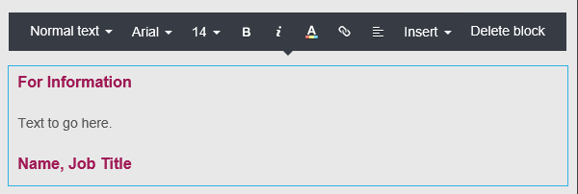

The text formatting should be as follows:

1. Description: This is almost always “For Information” – Ariel, bold, size 16, magenta colouring (a01a55). If the item in question is prompting a necessary response from schools, this can be changed to “For Action” – formatting the same but with red colouring (fa0d24)
2. The body text – Ariel, non-bold, size 14, grey colouring (565656)
3. The signature text, letting the reader know who the item has come from. Formatting is the same as “For Information”. This should include a name, job title, and (if not an E&S member of staff) their organisation. If the person comes from a different Barnet council department, their department name should be used rather than organisation name.

Paste the text each item at a time, proof reading and correcting as you go. If there is any trouble formatting text, try pasting into notepad first to remove the formatting, then pasting from notepad into Campaign Monitor.

**Common Text Corrections to Make**

1. Dates do not have superscripts (e.g., Wednesday 9 September, not Wednesday 9th September). Also, any dates must be ordered weekday/date/month/year.
2. Times -

* use ‘to’ in time ranges – not hyphens, rules or dashes, e.g. 10am to 11am (not 10–11am)
* Use 12 hour time, with dotes separating the hours and minutes rather than hyphens (for example: 5.30pm, not 1730hrs)
* midnight, not 00:00

1. “Headteacher” is one word and is *only* capitalised at the start of a sentence.
2. We cannot include tables or images in the body text of the circular. If tables are required, you will have to reformat the information so that it is conveyed in a different way. If this is impractical (for example, a very large table) save the table as a pdf and include it as an attachment, as described below.
3. Sentences, words, or phrases written in BLOCK CAPITALS are *not* allowed. Please re-write any phrases to use normal sentence case.
4. Remove any italics or bold text, as these are often used improperly. I only use bold text in the body text sparingly. For example: In an item that consisted of a list of different training sessions, I would bold the title of each training so that it is clear to the reader where new information starts. Also, if an item has lots of texts, and mentions a key date (submission date or deadline) towards the end of the text I will often bold that too.

**Finalising the draft**

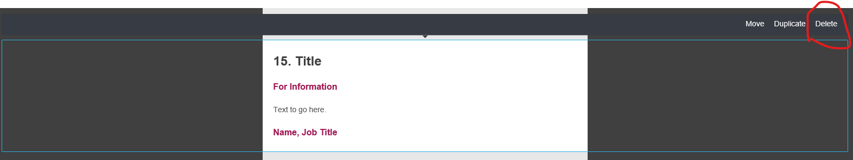Once the text is complete for all items, delete any unused text boxes as below. Click on the dark gray area to the side of the text box to bring up this menu:

Next, go back to the top of the draft and fill in the title of each item in the contents section, by copying and pasting.

**Adding the attachments**

Attachments for inclusion in the circular are to be saved in the “School Circular” folder in the S Drive. The location is:

S:\Education_&_Skills-016\BUSINESS_SUPPORT-016-03\COMMUNICATIONS\00_SCHOOL CIRCULAR\2019-20\2020 Spring Term

The items for each circular are filed in separate folders, arranged by date.

**Format**

Attachments must be in PDF format *unless there is a form to fill in or information to be entered by the school*. In this case it is acceptable to send as a word or excel file.

All enclosures saved in the S: drive should be given a number before their name corresponding to the number of item they are attached to in the circular. This makes keeping track of items much easier. See example below:

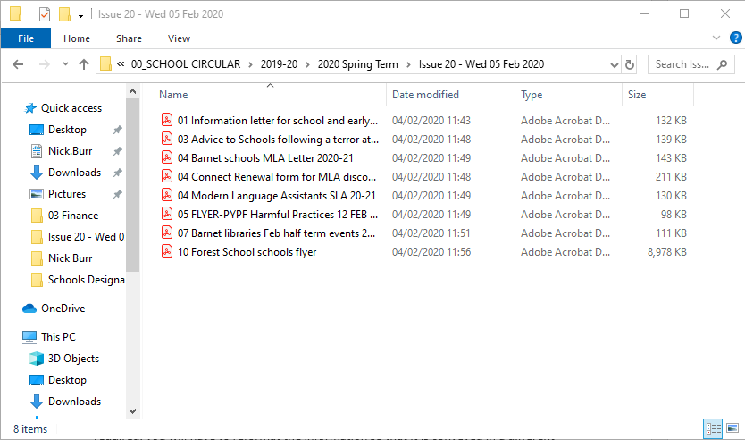

**Generating a URL for the attachments**

Documents cannot be uploaded directly to the circular, so to get around that, we host documents for the circular on the Working With Children in Barnet (WWCiB) website. We then copy this URL and use this to attach our attachments.

The procedure to attaching documents is outlined below:

1. Log on to the WWCiB site as described on the first page of this document. Note, this system (Drupal) *does not work on Internet Explorer* – you will have to use another browser. I use Microsoft Edge, you may try Google Chrome or Mozilla Firefox.
2. 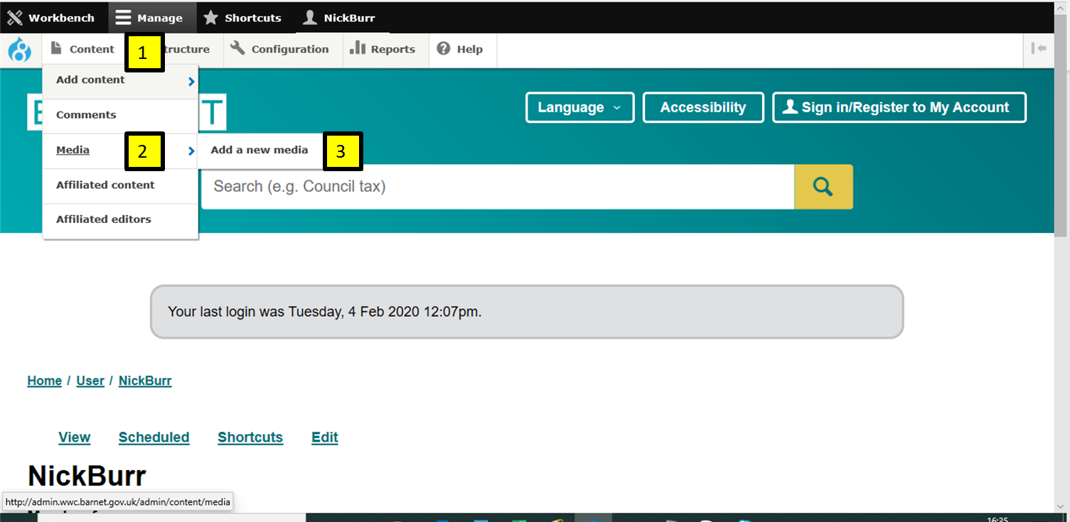After logging in, get to the document upload menu by highlighting the following options: Content (1), Media (2) and Add a new media (3):
3. On the next screen, click on “Documents”
4. On the following screen, click on the “Browse…” button and search the shared drive for the document. Once uploaded, copy the document name into the “Media name” bar at the top. In the “Domain Access” list, click to toggle on the WWC option. Then, head to the bottom of the page and click on the “Save and Publish” button
5. This will bring up a screen showing a link to the document. Right click on the document name to bring up a menu and select “Copy link”. This saves the URL for that document to your computer’s clipboard
6. *Return to your draft circular in Campaign Monitor.* Find the text where you would like to link your attachment to in its corresponding item (often this is a sentence such as “Please see the attached flyer”, etc.). Highlight this text, then select the “link” icon (to the right of the text colour icon). This will bring up a bar. You can paste your URL in here. Click on the green tick box, and the attachment will now link to that text.

Repeat this process for every attachment.

**Directors Sign-Off**

**Sending to the director**

By now, you should have a circular with:

1. All of the text filled in
2. All of the contents section filled in
3. All of the attachments added

Once these are finished, it is time to send to the director for a final sign off. A rough deadline for this is 12pm on a Tuesday.

*NOTE: If there are a lot of attachments, you can send the circular to the director for proof-reading without these, provided the text and contents are finished. If so, please point out in your email to them that the attachments have not been added yet.*

**Generating an email of the draft circular**

To send a draft to your inbox, click on the “Send a test email” button at the top of the screen in Campaign Monitor. This will bring up a pop-up – simply enter your email address into this and click “send test”. An email will arrive in your inbox in the next minute or two bearing the draft circular. If it does not, please check your spam or junk, as they can get sent there as well.

Forward this on to the director. In your email, you may wish to point out anything of note in this weeks circular (for example, if a member of E&S has forwarded on an item from an outside organisation to you, you will probably want to highlight this to the director, so they know that the information has been vouched for by a member of E&S).

The following people should be copied in to the draft:

* Jane Elliott, BSCT Manager
* Carrie Waldren, Training and Traded Services Co-ordinator
* Nick Burr, Communications Officer

The director should reply with any amendments they wish to be made. *If you have not received this email by Wednesday morning, chase the director immediately.*

Make any amendments that are requested by the director.