Scheme Name: Leeside, EN5
Our Ref.: BC/001749-01
Department: Environment directorate - Highways
Date: 24 July 2025
Contact Details: Highways Service
Tel. 020 8359 3555
HighwaysCorrespondence@Barnet.gov.uk

Dear Sir/Madam,

We are writing to you as part of the Council’s statutory consultation process to seek your views on our proposal to introduce new measures on Leeside, EN5. The proposals aim to improve safety for all road users, and in particular pedestrians.

The proposals incorporate the following road safety measures which are shown on the attached plan:

- Replace the existing uncontrolled crossing with a zebra crossing.
  - A buildout at the service road and drainage works are required at this location as part of the measures.
- Replace the existing “No Waiting or Loading at Any Time” parking restrictions with “Zig Zag” markings.

The proposals are illustrated on the enclosed drawing BC/001749-01_Leeside ZB_SC-100-RevC.

This letter is being sent to you as part of the council’s statutory consultation process for the proposals outlined above. The proposals are also being advertised in the Barnet Times and the London Gazette on 24 July 2025 and notices are also being put up in the area advising of the proposed changes.

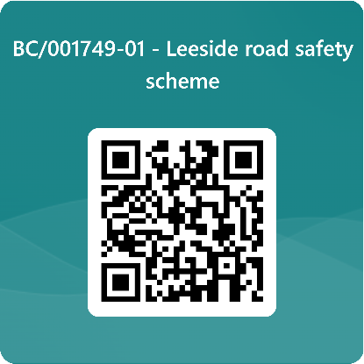
We want to hear from you

The consultation period commences on 24 July 2025. You can have your say on our proposals by completing our online questionnaire by scanning the QR code.

Alternatively, the questionnaire can be viewed here: https://forms.office.com/e/MJdDR4kavw

The closing date for the consultation is 21 August 2025.

If you are unable to complete the questionnaire online and would like to request a paper copy, please call Highways Correspondence section on 020 8359 3555 or email HighwaysCorrespondence@Barnet.gov.uk, quoting reference number BC/001749-01

Following the consultation close date, officers will review all feedback received and provide recommendations whether to progress the scheme, with or without modification, or not to progress. We will write to residents again ahead of implementing any final scheme.

Yours faithfully,
Highways Service.

