Scheme Name: Pollard Road
Our Ref.: HLIP02-05
Department: Environment directorate - Highways
Date: 24 July 2025
Contact Details: Highways Service
Tel. 020 8359 3555
HighwaysCorrespondence@Barnet.gov.uk

Dear Sir/Madam,
We are writing to you as part of the Council’s statutory consultation process to seek your views on our proposal to introduce new measures on Pollard Road, Russell Lane and Oakleigh Road North(A109). The proposals aim to improve safety for all road users, and in particular pedestrians.

The proposals incorporate the following road safety measures:

- Introduction of a no entry point except cyclist at Pollard Road, 25m from junction with Oakleigh Park North junction up to the junction itself.

- Upgrade existing zebra crossings on Russell Lane and Oakleigh Park North, to a zebra crossing atop a raised table to improve safety for pedestrian.

- Introduce a new uncontrolled crossing on Pollard Road, close to Oakleigh Park North, making a safer crossing place for pedestrians.

- Enhance the mouths of junctions by tightening the radius of kerb and introducing tactile paving, improving safety for pedestrians.

- Extending existing Zig Zag lines before the crossings to improve visibility for pedestrians and motorists.

The proposals are illustrated on the enclosed drawing HLIP02-05 Pollard Rd-SC-100.

This letter is being sent to you as part of the council’s statutory consultation process for the proposals outlined above. The proposals are also being advertised in the Barnet Times and the London Gazette on 24 July 2025 and notices are also being put up in the area advising of the proposed changes.

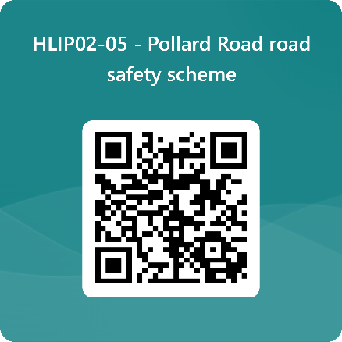
We want to hear from you

The consultation period commences on 24 July 2025. You can have your say on our proposals by completing our online questionnaire by scanning the QR code below.

Alternatively, the questionnaire can be viewed here: https://forms.office.com/e/NE6v4R19Cy

The closing date for the consultation is 21 August 2025.

If you are unable to complete the questionnaire online and would like to request a paper copy, please call Highways Correspondence section on 020 8359 3555 or email HighwaysCorrespondence@Barnet.gov.uk, quoting reference number HLIP02-05.

Following the consultation close date, officers will review all feedback received and provide recommendations whether to progress the scheme, with or without modification, or not to progress. We will write to residents again ahead of implementing any final scheme.

Yours faithfully,
Highways Service.

