Scheme Name: Wentworth Road
Our Ref.: RSE020
Department: Environment directorate - Highways
Date: 24 July 2025
Contact Details: Highways Service
Tel. 020 8359 3555
HighwaysCorrespondence@Barnet.gov.uk

Dear Sir/Madam,
We are writing to you as part of the Council’s statutory consultation process to seek your views on our proposal to introduce new measures on Wentworth Road, Ravenscroft Avenue and Templars Avenue. The proposals aim to improve safety for all road users, and in particular pedestrians.

The proposals incorporate the following road safety measures which are shown on the attached plan:

Ravenscroft Avenue junction with Templar Avenue:

- Changes to junction layout to assist pedestrians, reduce speed, enhance traffic flow and support visibility at junction. This includes introduction of:
  - build outs
  - uncontrolled crossings with tactile paving
  - raised tables
  - STOP signs and lines.

- Proposed changes to parking restrictions linked to the above measures to improve visibility:
  - 5.5 metres of existing "No Waiting" (single yellow line) operating Monday - Friday 11am to 12pm to be replaced with "No Waiting at Any Time" (double yellow line)
  - 12.6 metres of existing resident permit holders only (Zone H) operating Monday – Friday, 11am to 12pm, to be replaced with "No Waiting at Any Time" (double yellow line).

Ravenscroft Avenue junction with Wentworth Road:

- Changes to junction layout to assist pedestrians in reducing crossing distance, reduce speed, enhance traffic flow and support visibility at junction. This includes introduction of:
  - build outs
  - uncontrolled crossings with tactile paving
  - uncontrolled crossing with refuge island
  - introduction of speed cushions
  - STOP signs and lines

- Proposed changes to parking restrictions are linked to the above measures to improve visibility:
  - 5 metres of existing "No Waiting" (single yellow line) operating Monday - Friday 11am to 12pm to be replaced with "No Waiting at Any Time" (double yellow line)
  - 27 metres of existing resident permit holders only (Zone H) operating Monday - Friday 11am to 12pm to be replaced with "No Waiting at Any Time" (double yellow line).

The proposals are illustrated on the enclosed drawing RSE020 Wentworth Rd-SC-100_Rev2.

This letter is being sent to you as part of the council’s statutory consultation process for the proposals outlined above. The proposals are also being advertised in the Barnet Times and the London Gazette on 24 July 2025 and notices are also being put up in the area advising of the proposed changes.

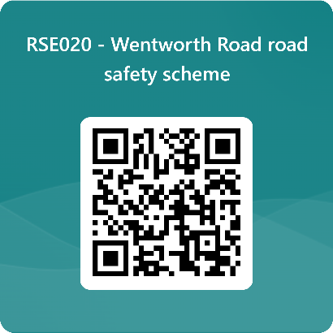
We want to hear from you

The consultation period commences on 24 July 2025. You can have your say on our proposals by completing our online questionnaire by scanning the QR code below.

Alternatively, the questionnaire can be viewed here: https://forms.office.com/e/S1Kj3Tn2DC

The closing date for the consultation is 21 August 2025.

If you are unable to complete the questionnaire online and would like to request a paper copy, please call Highways Correspondence section on 020 8359 3555 or email HighwaysCorrespondence@Barnet.gov.uk, quoting reference number RSE020.

Following the consultation close date, officers will review all feedback received and provide recommendations whether to progress the scheme, with or without modification, or not to progress. We will write to residents again ahead of implementing any final scheme.

Yours faithfully,
Highways Service.

