Scheme Name: Decoy Avenue
Our Ref.: RSE049
Department: Environment directorate - Highways
Date: 24 July 2025
Contact Details: Highways Service
Tel. 020 8359 3555
HighwaysCorrespondence@Barnet.gov.uk

Dear Sir/Madam,

We are writing to you as part of the Council’s statutory consultation process to seek your views on our proposals to introduce new measures on Decoy Avenue. The proposals aim to improve safety for all road users, and in particular pedestrians.

The proposals incorporate the following road safety measures which are shown on the attached plan:

- Changes to junction layout to assist pedestrians, reduce speed, enhance traffic flow and support visibility at junction. This includes:
  - Installing raised tables at the junctions
  - Widening the footway
  - Introducing uncontrolled crossing points, including tactile paving

- Installing double yellow lines at various locations to improve visibility and further enhance road safety.

- Introducing a splitter island outside house numbers 9 and 14 to improve traffic flow, reduce vehicular speeds and improve safety.

The proposals are illustrated on the enclosed drawing RSE049 Decoy Av-SC-100.

This letter is being sent to you as part of the council’s statutory consultation process for the proposals outlined above. The proposals are also being advertised in the Barnet Times and the London Gazette on 24 July 2025 and notices are also being put up in the area advising of the proposed changes.

We want to hear from you
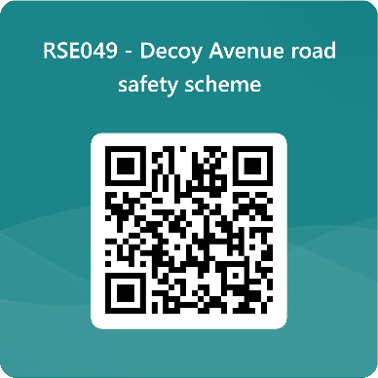
The consultation period commences on 24 July 2025. You can have your say on our proposals by completing our online questionnaire by scanning the QR code below.

Alternatively, the questionnaire can be viewed here: https://forms.office.com/e/DcpCmyuQwX

The closing date for the consultation is 21 August 2025.

If you are unable to complete the questionnaire online and would like to request a paper copy, please call Highways Correspondence section on 020 8359 3555 or email HighwaysCorrespondence@Barnet.gov.uk, quoting reference number RSE049.

Following the consultation close date, officers will review all feedback received and provide recommendations whether to progress the scheme, with or without modification, or not to progress. We will write to residents again ahead of implementing any final scheme.

Yours faithfully,
Highways Service.

