Scheme Name: Fernside
Our Ref.: RSW016
Department: Environment directorate - Highways
Date: 24/07/2025
Contact Details: Highways Service
Tel. 020 8359 3555
HighwaysCorrespondence@Barnet.gov.uk

Dear Sir/Madam,
We are writing to you as part of the Councils statutory consultation process to seek your views on our proposal to introduce new road safety measures on Fernside, NW11, at the junction of West Heath Avenue. The proposal aims to improve safety for all road users by reducing congestion in the area.

Due to the traffic light signals located at West Heath Avenue, directly next to the Fernside entry / exit point, Fernside can become quickly blocked by vehicles waiting at the red traffic signal. In turn, this can lead to vehicles looking to turn right onto Fernside creating a backlog onto the junction.

The proposal incorporates the following engineering measures which are shown on the below plan:

- Make Fernside ‘No Entry’ for vehicles turning left or right from West Heath Avenue.

The proposal includes a ‘No Entry’ sign and road markings associated to the restriction that will close Fernside at the junction with West Heath Avenue. The junction will be exit only from Fernside into West Heath Drive, with vehicles only being able to enter Fernside from Finchley Road.
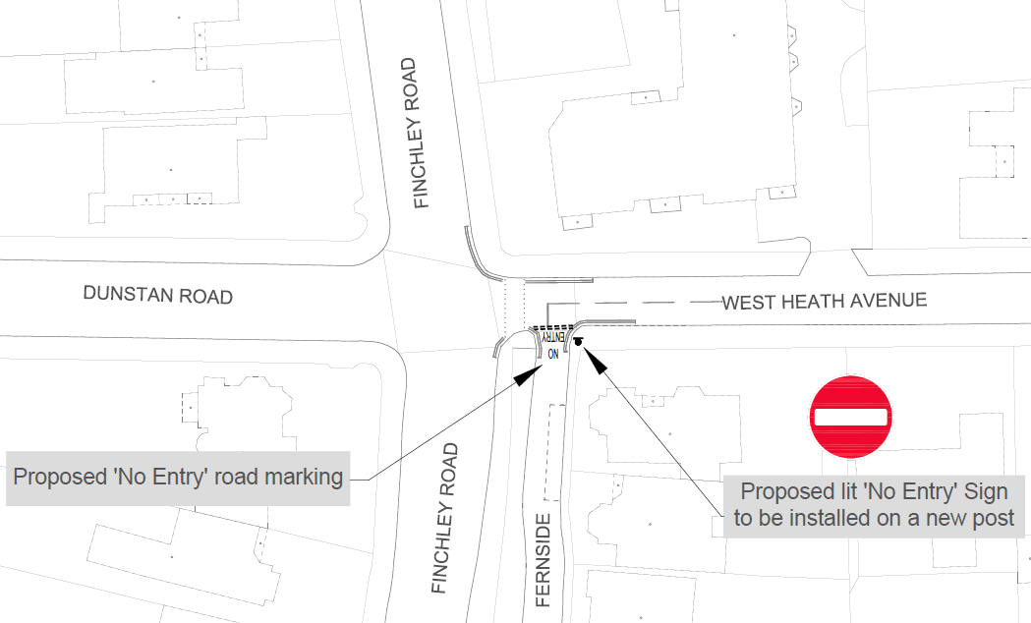

This letter is being sent to you as part of the council’s statutory consultation process for the proposals outlined above. The proposals are also being advertised in the Barnet Times and the London Gazette on 24 July 2025 and notices are also being put up in the area advising of the proposed changes.

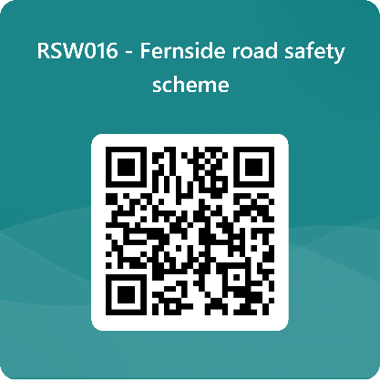
We want to hear from you

The consultation period commences on 24 July 2025. You can have your say on our proposals by completing our online questionnaire by scanning the QR code below.

Alternatively, the questionnaire can be viewed here: https://forms.office.com/e/DCceD6ms6s

The closing date for the consultation is 21 August 2025.

If you are unable to complete the questionnaire online and would like to request a paper copy, please call Highways Correspondence section on 020 8359 3555 or email HighwaysCorrespondence@Barnet.gov.uk, quoting reference number RSW016.

Following the consultation close date, officers will review all feedback received and provide recommendations whether to progress the scheme, with or without modification, or not to progress. We will write to residents again ahead of implementing any final scheme.

Yours faithfully,
Highways Service.

