Scheme Name: Finchley Police Station, Ballards Lane
Our Ref.: HAS009
Department: Environment directorate - Highways
Date: 25 September 2025
Contact Details: Highways Service
Tel. 020 8359 3555
HighwaysCorrespondence@Barnet.gov.uk

Dear Sir/Madam,
We are writing to you as part of the Councils statutory consultation process to seek your views on our proposal to introduce new measures on Ballards Lane, N3. The proposals aim to improve safety for all road users, and in particular pedestrians.

The proposals incorporate the following engineering measures which are shown on the attached plan:

- Widening existing pedestrian island and installing blister tactile paving to mark the crossing point for visually impaired people.

- Introducing buildouts at both sides of the crossing to reinforce existing crossing point, improve intervisibility and enhance safety.
The proposals are illustrated on the enclosed drawing HAS009_Ballards Lane_SC-100.

This letter is being sent to you as part of the council’s statutory consultation process for the proposals outlined above. The proposals are also being advertised in the Barnet Times and the London Gazette on 25 September 2025, and notices are also being put up in the area advising of the proposed changes.

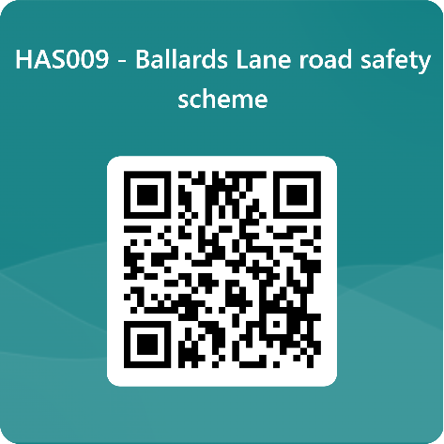
We want to hear from you

The consultation period commences on 25 September 2025. You can have your say on our proposals by completing our online questionnaire by scanning the QR code.

Alternatively, the questionnaire can be viewed here: https://forms.office.com/e/79FMwzi8cK

The closing date for the consultation is 16 October 2025.

If you are unable to complete the questionnaire online and would like to request a paper copy, please call Highways Correspondence section on 020 8359 3555 or email HighwaysCorrespondence@Barnet.gov.uk, quoting reference number HAS009.

Following the consultation close date, officers will review all feedback received and provide recommendations whether to progress the scheme, with or without modification, or not to progress. We will write to residents again ahead of implementing any final scheme.

Yours faithfully,
Highways Service.

