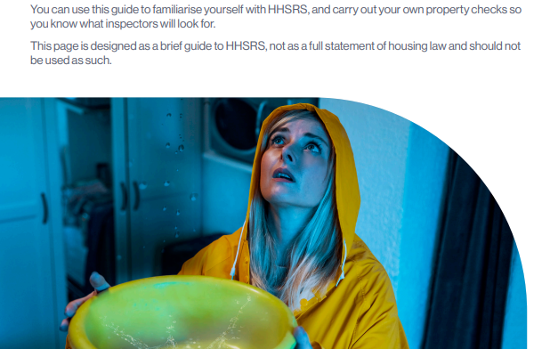

**For more information on HHSRS go to https://england.shelter.org.uk/professional_resources/legal/housing_conditions/local_authority_duties_to_deal_with_poor_conditions/hhsrs_definition_of_hazards#the-housing-health-and-safety-rating-system**