Scheme Name: Pattison Road, NW2
Our Ref.: HLIP02-06
Department: Environment directorate - Highways
Date: 25 September 2025
Contact Details: Highways Service
Tel. 020 8359 3555
HighwaysCorrespondence@Barnet.gov.uk

Dear Sir/Madam,

We are writing to you as part of the Council’s statutory consultation process to seek your views on our proposal to introduce new measures on Pattison Road, NW2. The proposals aim to improve safety for all road users, and in particular pedestrians.

The proposals incorporate the following engineering measures which are shown on the attached plan:

- Introduction of 20mph speed limit on Pattison Road with signs and road markings associated with this restriction

- Installation of new speed cushions outside number 41 and numbers 19 and 21

This letter is being sent to you as part of the council’s statutory consultation process for the proposals outlined above. The proposals are also being advertised in the Barnet Times and the London Gazette on 25 September 2025 and notices are also being put up in the area advising of the proposed changes.

The proposals are illustrated on the enclosed drawing.

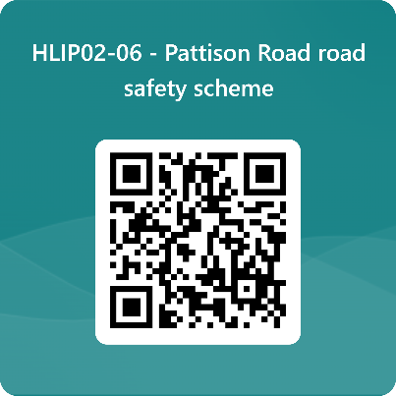
We want to hear from you

The consultation period commences on 25 September 2025. You can have your say on our proposals by completing our online questionnaire by scanning the QR code.

Alternatively, the questionnaire can be viewed here: https://forms.office.com/e/d63nLvLFrw

The closing date for the consultation is 16 October 2025.

If you are unable to complete the questionnaire online and would like to request a paper copy, please call Highways Correspondence section on 020 8359 3555 or email HighwaysCorrespondence@Barnet.gov.uk, quoting reference number HLIP02-06.

Following the consultation close date, officers will review all feedback received and provide recommendations whether to progress the scheme, with or without modification, or not to progress. We will write to residents again ahead of implementing any final scheme.

Yours faithfully,
Highways Service


