Scheme Name: Market Place, N2
Our Ref.: RSE054
Department: Environment directorate - Highways
Date: 25 September 2025
Contact Details: Highways Service
Tel. 020 8359 3555
HighwaysCorrespondence@Barnet.gov.uk

Dear Sir/Madam,
We are writing to you as part of the Council’s statutory consultation process to seek your views on our proposal to introduce new measures on Market Place, N2. The proposals aim to improve safety for all road users, and in particular pedestrians.

The proposals incorporate the following engineering measures which are shown on the attached plan:

- Introduction of a raised table and footway buildout, widening the pavement at the junction with East End Road to improve safety for pedestrians crossing.

- Existing parking and waiting single yellow line restrictions (No Waiting Mon-Sat 8am-6:30pm) to be replaced with double yellow lines (No Waiting at any time) restrictions at the eastern side of the footway by the junction with East End Road.

- Introduction of a tree pit on the western side of the footway, within the new buildout created.

- Installation of cycle racks / public cycle parking on the western side of the footway within the new buildout created.

The proposals are illustrated on the enclosed drawing RSE054_Market Place_SC-100

This letter is being sent to you as part of the council’s statutory consultation process for the proposals outlined above. The proposals are also being advertised in the Barnet Times and the London Gazette on 25 September 2025 and notices are also being put up in the area advising of the proposed changes.

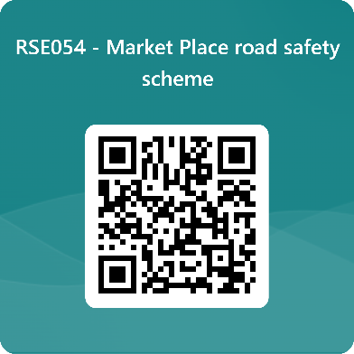
We want to hear from you

The consultation period commences on 25 September 2025. You can have your say on our proposals by completing our online questionnaire by scanning the QR code below.

Alternatively, the questionnaire can be viewed here: https://forms.office.com/e/ekdhX9KBwz

The closing date for the consultation is 16 October 2025.

If you are unable to complete the questionnaire online and would like to request a paper copy, please call Highways Correspondence section on 020 8359 3555 or email HighwaysCorrespondence@Barnet.gov.uk, quoting reference number RSE054.

Following the consultation close date, officers will review all feedback received and provide recommendations whether to progress the scheme, with or without modification, or not to progress. We will write to residents again ahead of implementing any final scheme.

Yours faithfully,
Highways Service.

