Scheme Name: Daws Lane_Etz Chaim School
Our Ref.: RSN025
Department: Environment directorate - Highways
Date: 25 September 2025
Contact Details: Highways Service
Tel. 020 8359 3555
HighwaysCorrespondence@Barnet.gov.uk

Dear Sir/Madam,

We are writing to you as part of the Council’s statutory consultation process to seek your views on our proposal to introduce new measures on Daws Lane, NW7. The proposals aim to improve safety for all road users.

The proposals incorporate the following engineering measures which are shown on the attached plan:

- Relocation of the existing 'Birkbeck Road Bus Stop' from its current position in front of Etz Chaim Primary School to a new location opposite number 25 on Daws Lane

- Installation of standard guard rails outside the entrance of Etz Chaim Primary School

- Changes on existing parking restriction:
  - Replacing the existing bus cage with "No waiting at any time" (double yellow lines).
  - Introduction of “School Keep Clear” road markings outside Etz Chaim Primary School operating Monday - Friday: 8am to 9:30am and 3pm to 4:30pm.
  - Replacing 24 metres of "Resident permit holders only (Zone E) Mon-Fri 11am to 12pm" with a new bus cage.
  - Replacing 6 metres of “Resident permit holders only (Zone E) Mon-Fri 11am to 12pm" with “No waiting at any time” (double yellow lines).
  - Replacing 39.8 metres of "No waiting Mon-Fri 11am to 12pm" (single yellow line) with "No waiting at any time" (double yellow lines).
  - Replacing 29 metres of "No waiting Mon-Fri 11am to 12pm" (single yellow line) to with “Resident permit holders only (Zone E) Mon-Fri 11am to 12pm".

The proposals are illustrated on the enclosed drawing RSN025_Daws Lane_100.

This letter is being sent to you as part of the council’s statutory consultation process for the proposals outlined above. The proposals are also being advertised in the Barnet Times and the London Gazette on 25 September 2025 and notices are also being put up in the area advising of the proposed changes.

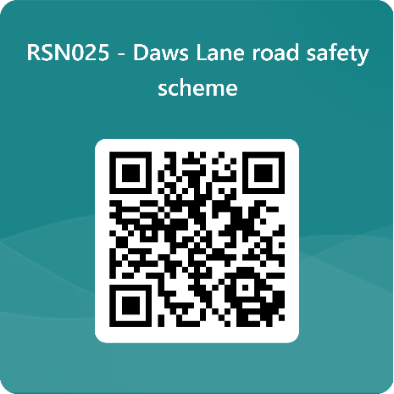
We want to hear from you

The consultation period commences on 25 September 2025. You can have your say on our proposals by completing our online questionnaire by scanning the QR code.

Alternatively, the questionnaire can be viewed here: https://forms.office.com/e/GvNFUARG8V

The closing date for the consultation is 16 October 2025.

If you are unable to complete the questionnaire online and would like to request a paper copy, please call Highways Correspondence section on 020 8359 3555 or email HighwaysCorrespondence@Barnet.gov.uk, quoting reference number RSN025.

Following the consultation close date, officers will review all feedback received and provide recommendations whether to progress the scheme, with or without modification, or not to progress. We will write to residents again ahead of implementing any final scheme.

Yours faithfully,
Highways Service

